**Commodore VIC-20 A/V-Adapter Rev. 2**

**Test**

# Test Setup

The tests were executed with a VIC-20 A/V-Adapter Rev. 1 and Rev. 2. These computers were used for testing:

1. A VickyTwenty (clone of the VIC-20CR) in a plexilaser.de case
2. A two-prong VIC-20 (ASSY No. 324003)
3. A VIC-20CR (ASSY No. ASSY250403)
4. C64 ASSY No. 250469

The VickyTwenty has the S-Video modification ([sleepingelephant.com](http://sleepingelephant.com/denial/wiki/index.php?title=S-Video_output) or [tech.guitarsite.de](http://tech.guitarsite.de/vicky20_smod.html), respectively).

The retroTINK 2x (used with the HDMI capture device), the Framemeister (used with the TV) and a Samsung smart TV served as video equipment. A 1.5m RCA A/V cable connected the computer to the video equipment.

# Functional Test

The A/V adapter was connected to the computers and the video was displayed properly, the audio could be heard.

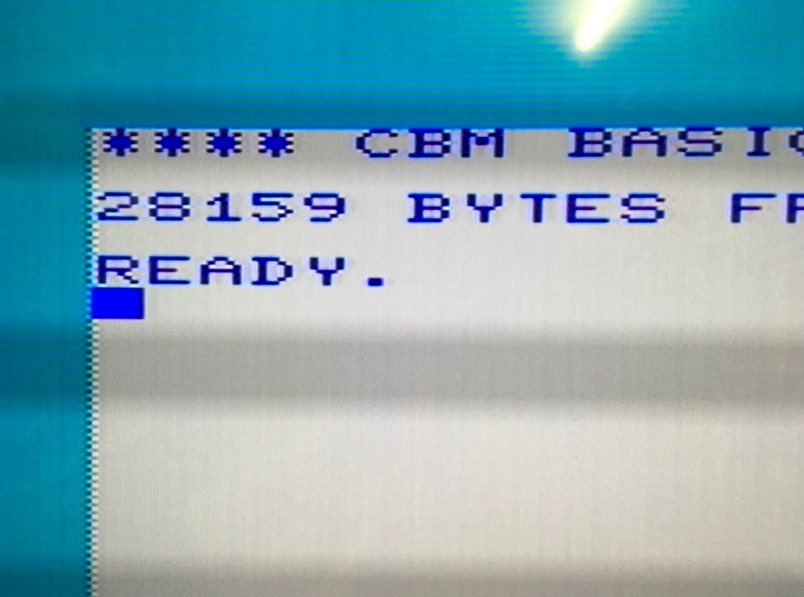

Figure 1: Boot screen of the VIC-20 CR (Hyper Expander RAM expansion installed)

The video quality was as good as it can get with the unmodified VIC-20. The video quality of ASSY No. 324003 is best, next is the Vicky Twenty.

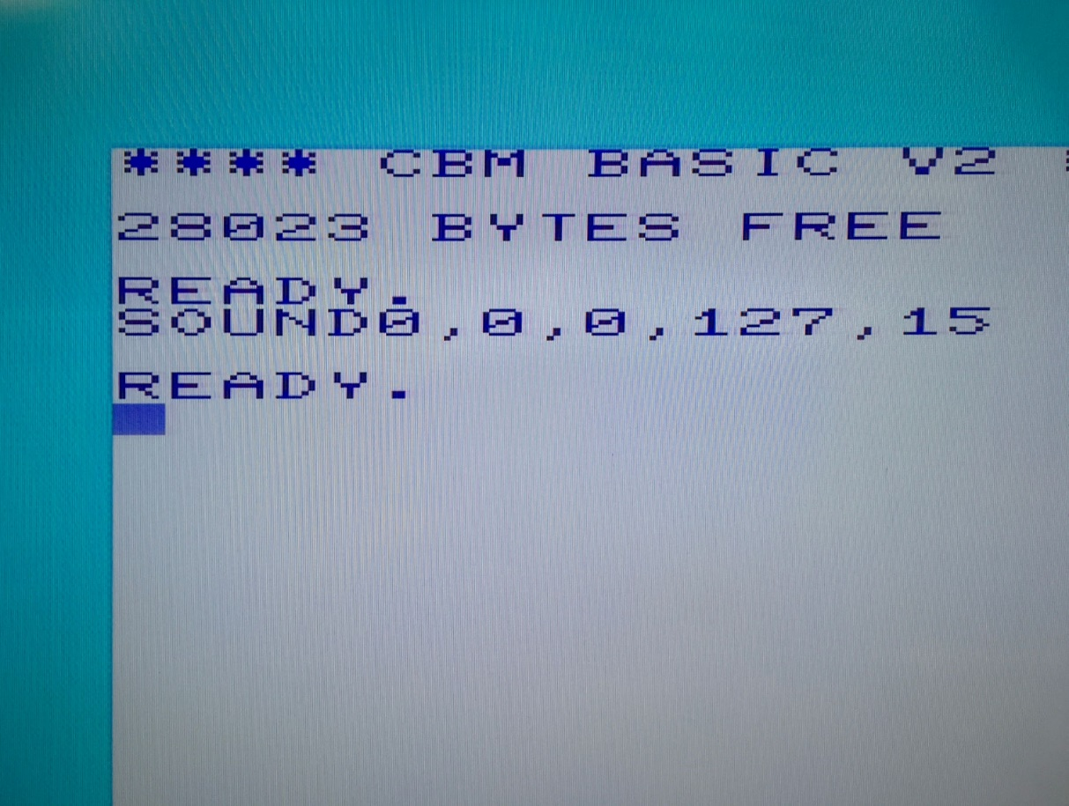

Figure 2: Photo of the BASIC start up screen of the VickyTwenty with the S-Video mod

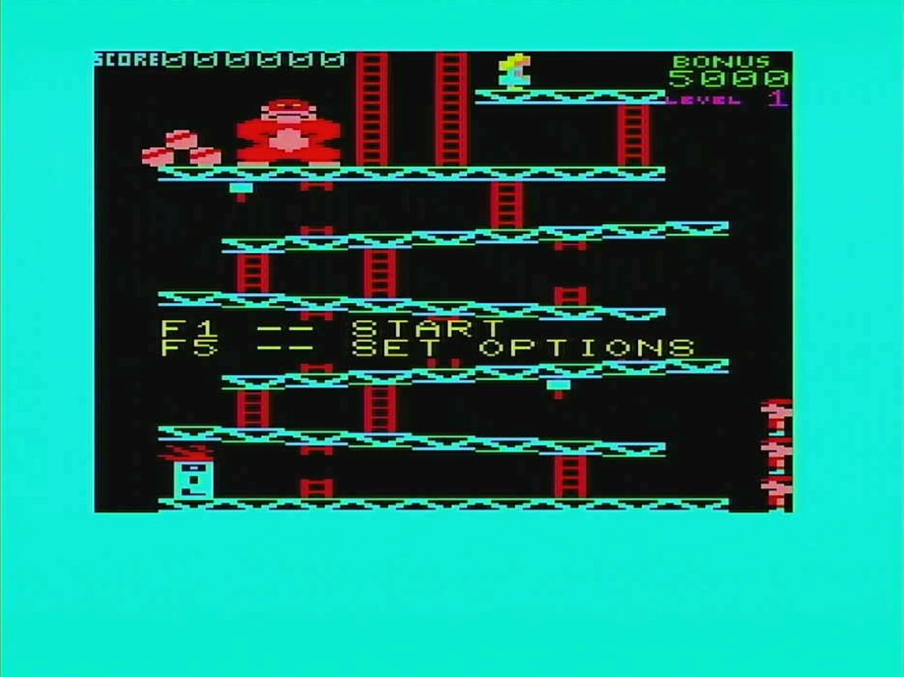

Figure 3: Donkey Kong on the VickyTwenty/S-Video mod

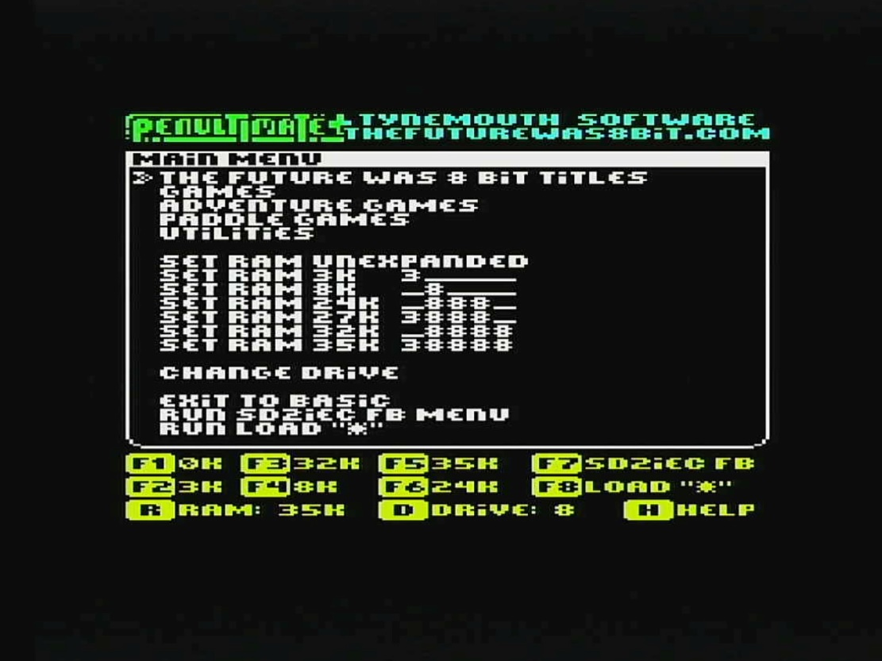

Figure 4: PENULTIMATE+ Cartridge on VickyTwenty / S-Video mod

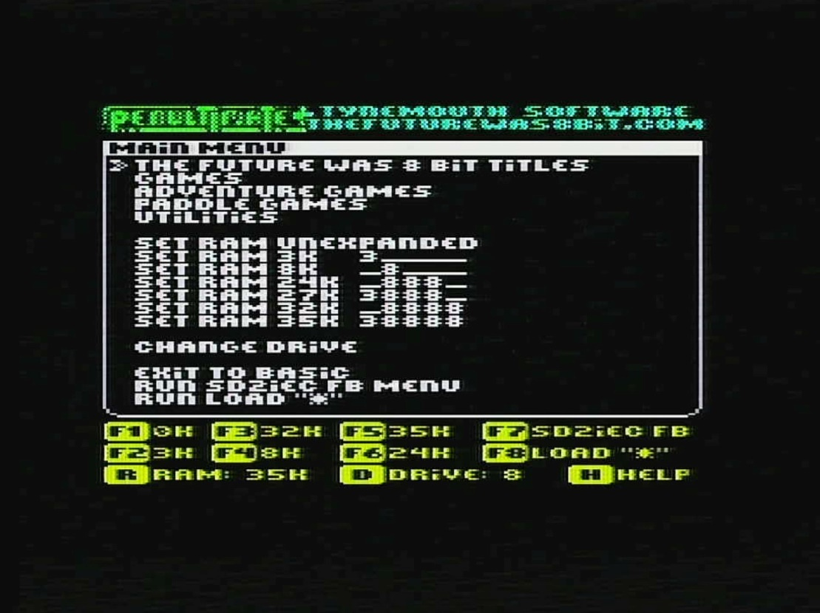

Figure 5: PENULTIMATE+ Cartridge (composite video) on a VIC-20CR

The improvement due to the S-Video mod is obvious when comparing Figure 4 and Figure 4Figure 5.

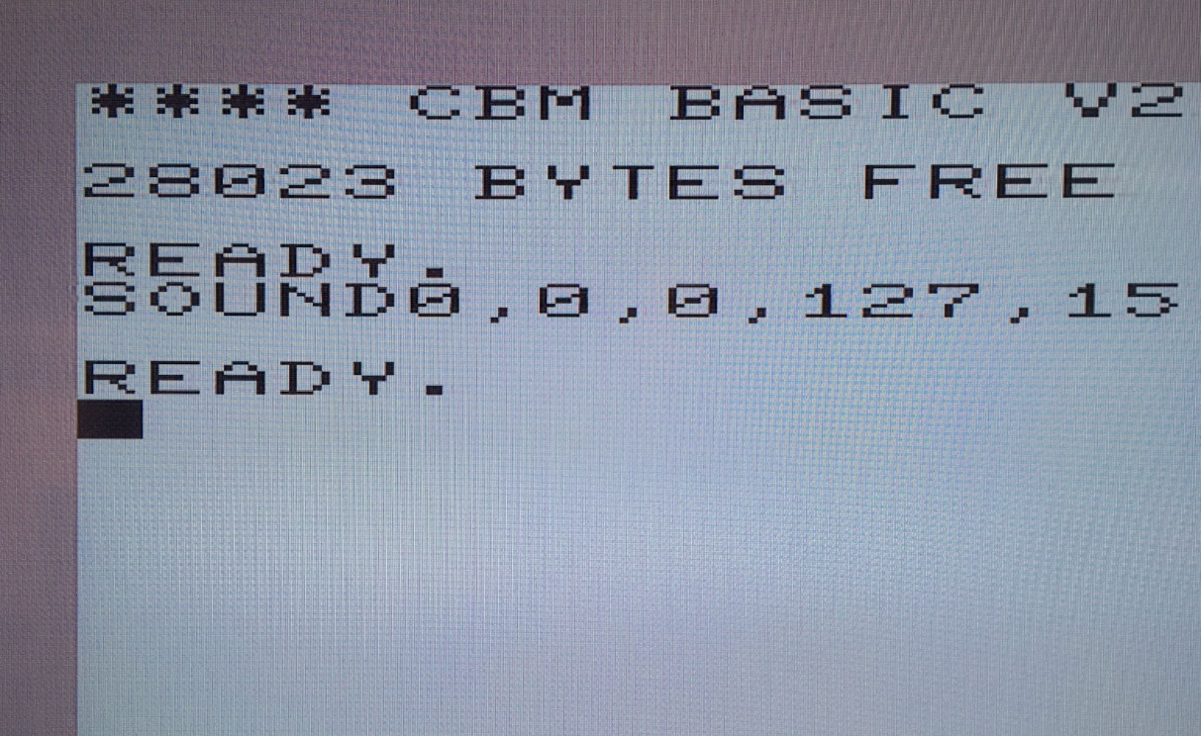

Figure 6: Composite output of the S-Video modded VickyTwenty (photo)

**As expected**, the composite output of the VickyTwenty with S-Video mod produces a black&white picture only, since the composite output is now luminance.

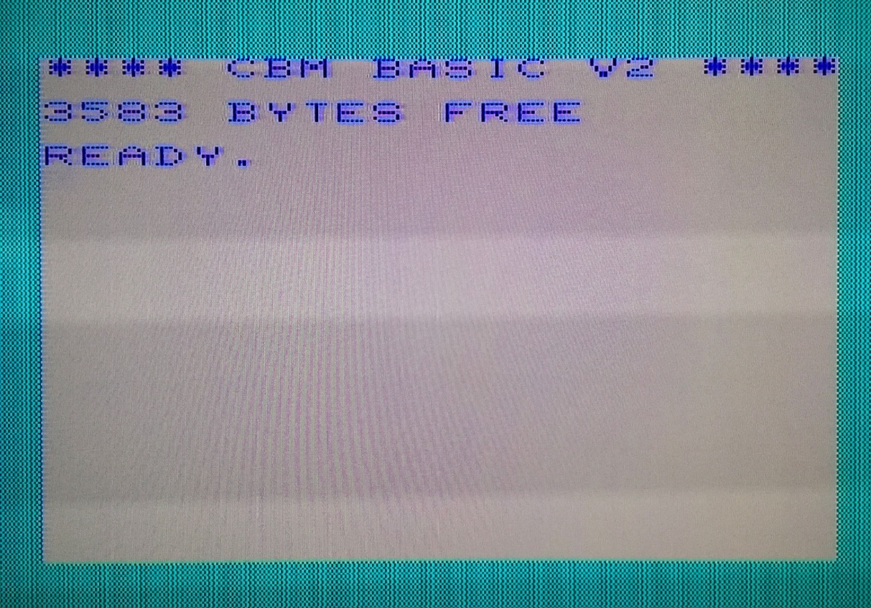

Figure 7: S-Video output of a VIC-20CR **without** the S-Video mod on a Framemeister

**As expected**, the video quality is low from the s-video jack on an unmodified VIC-20CR. Here, pin 4 and pin 5 of the A/V jack are both composite (instead of luma/chroma for S-Video).

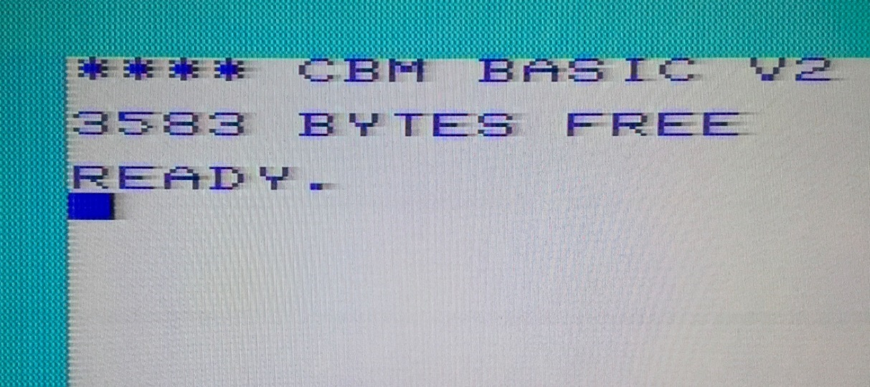

Figure 8: S-Video output of the unmodified VIC-20 (2 prong)

As expected, the output is degraded. The 2-prong VIC-20 has a different video circuitry as the VIC-20CR. Pin 4 and pin 5 are not tied together, but pin 4 is a composite signal (Pin 5) after an L/C-low pass filter. Thus, the different output “quality” of incorrectly connected VIC-20s.

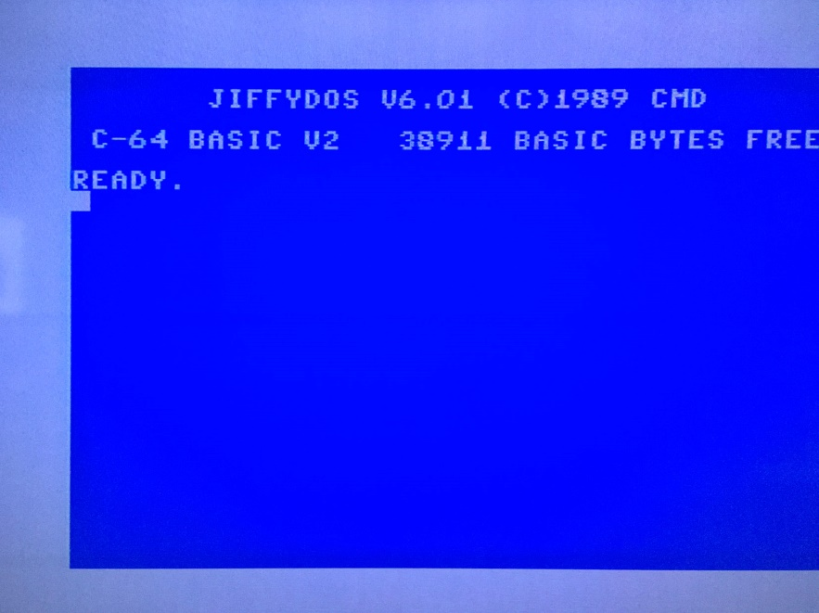

Figure 9: Photo of the C64 boot screen (composite Video)

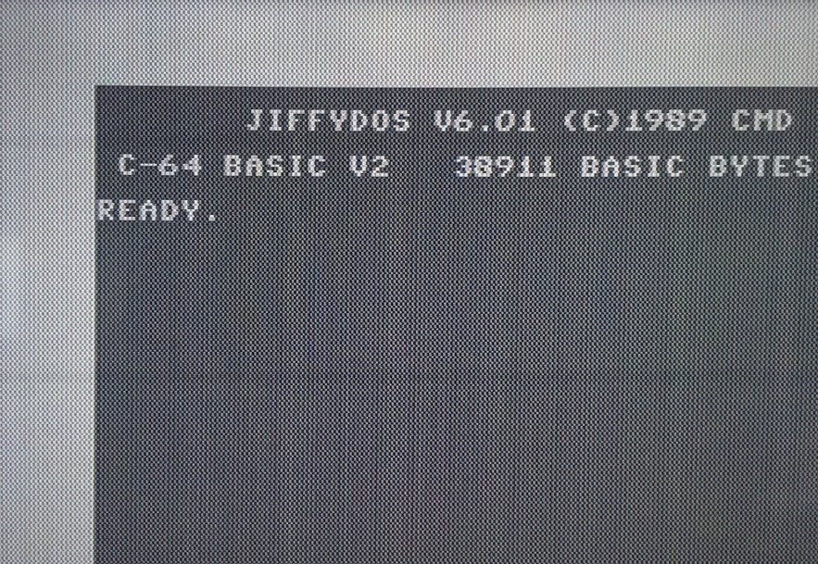

Figure 10: C64 S-Video output

**As expected**, the S-Video output of the C64 does not work properly. The display is black and white, since Pin 5 (which is chrominance on a modified VIC-20) is audio in on the C64. Neither the C64 nor the Framemeister were harmed during this experiment.

# Mechanical Testing

The VIC-20 A/V adapter did not block any port of the said computers.

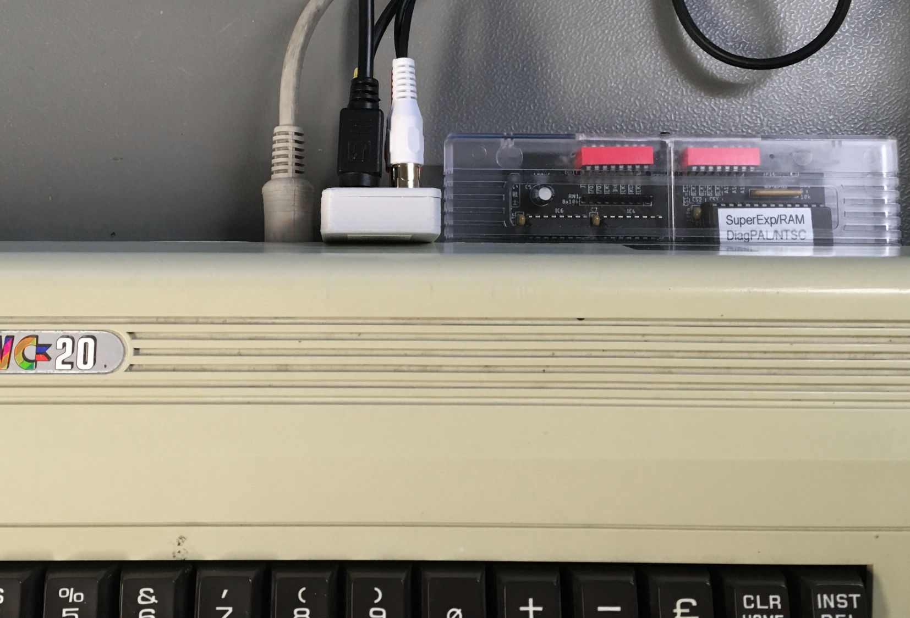

Figure 11: Testing the A/V adapter with a two-prong VIC-20

Again, the connection is stable and no ports are blocked with the ASSY No. 324003 two-prong VIC-20.

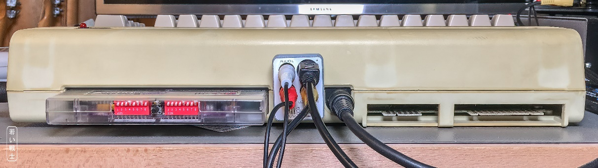

Figure 12: Fitting of the A/V-Adapter with a VIC-20CR

# Conclusion

The VIC-20 A/V-Adapter works well with different equipment. The video quality depends very much on the used video equipment. The video adapter will not improve the picture of the computers, since it is passive only, but since it allows to use good, off the shelve cables, it is superior to most hand-made custom cables.

Connecting S-Video to not modified VIC-20s does not harm the video equipment or the computer, but the quality is degraded. The same applies to the C64, which has its dedicated S-Video pins, that are not connected to the S-Video jack of the VIC-20 A/V-Adapter. The composite out of the C64 is displayed properly through the VIC-20 A/V-Adapter.

The VIC-20 A/V-Adaptor Rev. 2 is fully functional.